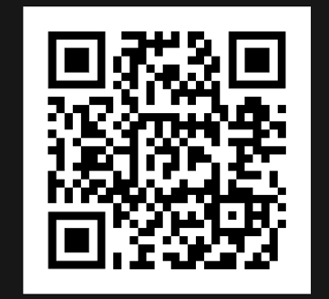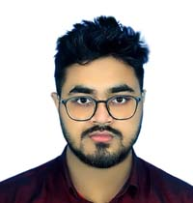

* Collaborated with a cross-functions team to enhance an existing mobile app, resulting in a 30% increase in user engagement.
* Implemented new features and conducted through testing, identifying and resolving critical bugs to ensure a smooth user experience.

Enthusiastic and creative computer science student with a passion for solving complex problems through innovative solutions. Eager to contribute my skills in coding, software development, and teamwork to a dynamic and forward-thinking organization.

* 01310-990177
* mehedi.@gmail.com
* Kurigram,Rangpur

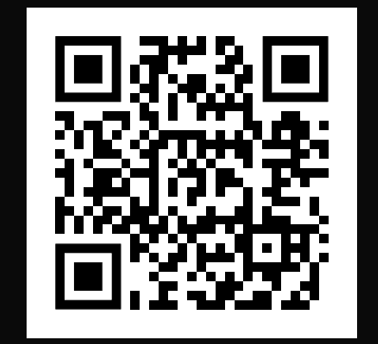

* **Bachelor of Science in Computer Science**

University: PSTU

Passing Year: 2020 May

Result: CGPA 3.50 Out of 4.00

PSTU Tech Solutions, TechTown | January 2020

**Training Title**: Practical SEO

**Duration**  : 1 Month

**Time Period** : 14-05-2020 To 29-06-2020

**Institution**  : BITM

SKILL ENHANCEMENT TRAINING

EDUCATIONAL QUALIFICATIONS

* **Software Development Intern**

PROFESSIONAL EXPERIENCE

CAREER OBJECTIVE

* Public Speaking
* Arts
* Volunteer Work &

Fundraising

Extracurricular Activities

* English-A1
* Garman-C2
* Spanish-A2

Languages

* Project management
* Strong decision maker
* Complex problem solver
* Creative design
* Innovative
* Service focused

Expertise

Contact Details

Computer Engineer

MD.MEHEDI HASAN